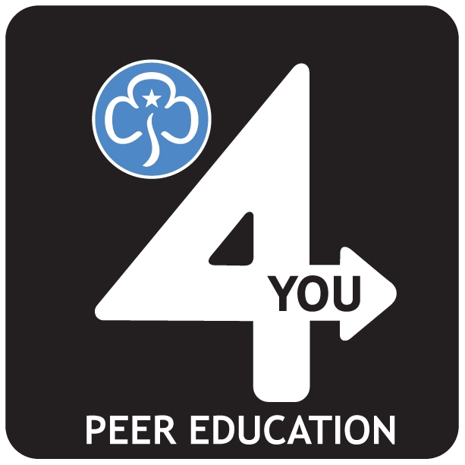
Issue of Gold Peer Educator Pin Badge

The Peer Educator pin badge is awarded once a Peer Educator has done their first four sessions (they do not have to be delivered in a set time).

For you as a Peer Educator to receive your badge:
- You need to ensure you have recorded your sessions on: www.girlguiding.org.uk/4sessions
- You need to complete this form and send it to your Peer Education Coordinator
- The Coordinator signs the form, and emails it to the Peer Education Team at HQ on 4peereducation@girlguiding.org.uk
- Once authorised, the badge is sent to the local coordinator and awarded to the Peer Educator.

Peer Educator Details
Name
Membership Number
Basic Training Attended
Date of Training
Details of peer education sessions
Topic |  | Number of sessions
Free Being Me
Think Resilient
Breaking Free
Safe the world
Other (pre FBM)

Coordinator Confirmation
- I confirm that the member above is a Peer Educator
- I confirm that the member above is an active Peer Educator within the County

Signature and Date

Name (in capitals)
Membership Number

Please confirm the name and address you would like the badge sent to:

Office Use Only
Date Received: |  | Authorised By:
Badge sent to:

